Experiment 9: Travelling Salesman Problem (TSP)

Aim
To develop a Python program to solve the Travelling Salesman Problem (TSP) by finding the shortest possible route that visits each city exactly once and returns to the starting city.

Objective
To demonstrate how the Travelling Salesman Problem can be solved by evaluating all possible routes and selecting the minimum-cost tour.

Algorithm
- Start.
- Read the distance matrix and select the starting city.
- Generate all possible routes that visit each city exactly once and return to the starting city.
- Calculate the total distance of each route and select the route with the minimum cost.
- Display the shortest route and minimum distance, then
- Stop.

SAMPLE CODE
from itertools import permutations
graph = [
[0, 10, 15, 20],
[10, 0, 35, 25],
[15, 35, 0, 30],
[20, 25, 30, 0]
]
n = len(graph)
cities = list(range(n))
min_cost = float('inf')
best_path = ()
for path in permutations(cities[1:]):
current_path = (0,) + path + (0,)
cost = 0
for i in range(len(current_path) - 1):
cost += graph[current_path[i]][current_path[i + 1]]
if cost < min_cost:
min_cost = cost
best_path = current_path
print("Shortest Path:", best_path)
print("Minimum Cost:", min_cost)

FLOW CHART
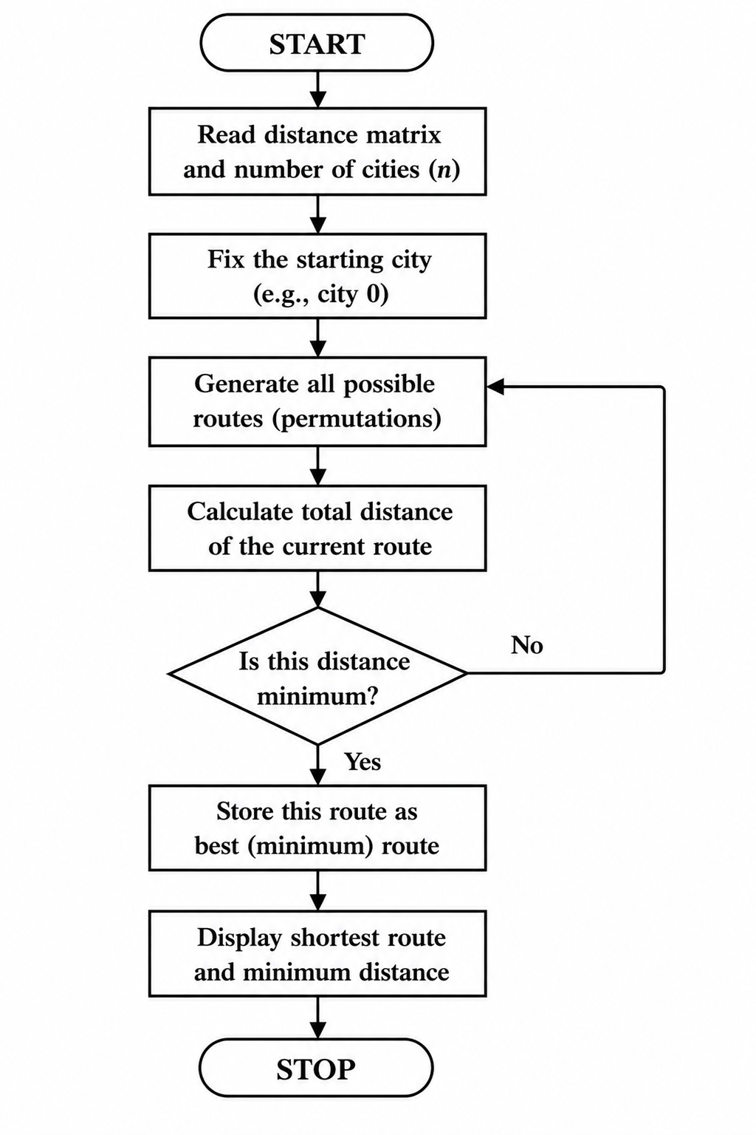

OUTPUT
RESULT
The Python program was executed successfully. The Travelling Salesman Problem was solved by finding the shortest route that visits each city exactly once and returns to the starting city with the minimum travel cost.

